## Special instructions to update GPX Manager to Dec 03, 2020 version

This update was issued because we had to change devices IDs of the GPS units. Formerly, device IDs were based on serial numbers that were detected by the computers every time a GPS unit is connected, via USB, to a computer. Unfortunately, the detected serial numbers are not the same as the Garmin issued serial numbers, hence there is no guarantee of uniqueness.

The solution was to let users create device IDs with GPX Manager guaranteeing uniqueness of the IDs.

With this update, the backend database should be changed. [Get a blank copy of the database](https://github.com/raffyMartinez/GPXManager/files/5543780/gpx.manager.blank.database.zip) and use this to replace the backend that is used by GPX Manager.

Just copy the new blank database to the folder where GPX Manager is installed. Just rename the file. From the settings window, change the backend database as shown and locate the new blank MDB file.

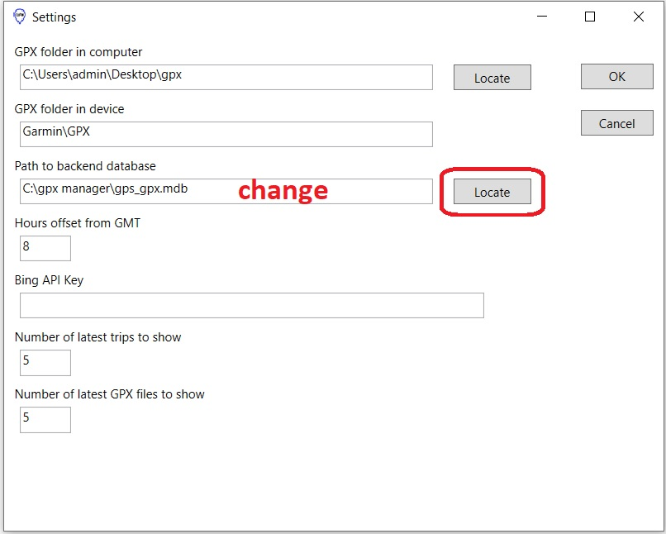

Restart GPX Manger and repeat the enrollment of GPS devices.